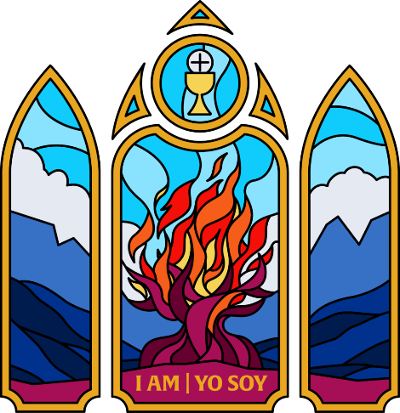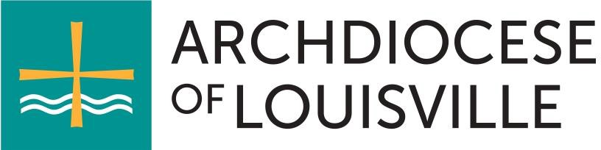

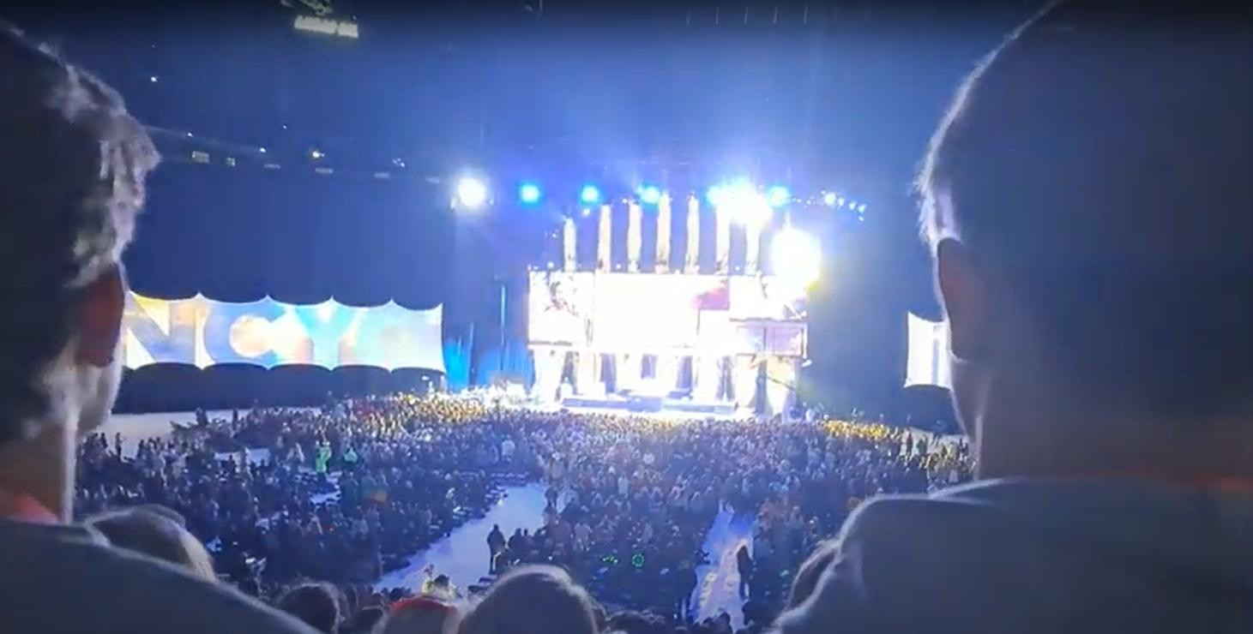

# Table of Contents

NCYC – WHAT, WHEN, AND WHERE? 3

What is NCYC? 3

Who puts on NCYC? 3

How is NCYC organized and managed within the Archdiocese of Louisville? 3

When and where will NCYC be held? 3

What is the theme for NCYC? 3

What’s the schedule for NCYC? 3

Will Archbishop Shelton be joining us at NCYC? 4

Is space limited? 4

I was a parish group leader for the 2023 NCYC. Any changes to the archdiocesan package this year? 4

NCYC—Who and Why? 4

Who can attend NCYC 2025? 4

Why would our youth want to attend NCYC? 5

Will participants miss any school? 6

Lodging, Transportation, and Meals 6

Where will we be staying? 6

Is a coach bus included in the archdiocesan package? 6

What meals are included? 6

Cost 7

How much will it cost? What is included? 7

What’s not included? 7

Are parishes and schools required to organize fundraisers for NCYC? 7

Are scholarships available? 7

Is the archdiocese making money on this event? 8

Organizing Parish Groups 8

Who organizes NCYC at the parish or school level? 8

What are the initial steps to get our parish or school organized? 8

How does the ArchLou NCYC package registration work? 8

Are NCYC Passes nonrefundable? Can they be transferred? 9

What is the refund policy? 9

When will the archdiocese need the names of my participants and chaperones? 9

What about safety and security? 10

I want to put the NCYC logo on my promotional material or group t-shirts. Where can I get a copy? 10

What if I have a student with special needs? 10

Can youth from another parish or school come with my parish? 10

How can I get more information? 10

# NCYC – WHAT, WHEN, AND WHERE?

**What is NCYC?** The National Catholic Youth Conference, or more commonly NCYC ([webpage](https://ncyc.us/about/); [video](https://youtu.be/8PWWQWu37IA)), is a multi-day Catholic pilgrimage for high school students and their chaperones in which teens and their chaperones discover and celebrate their faith and experience the larger Church. The [NCYC schedule](https://ncyc.us/program/schedule/) includes general and breakout sessions addressing various topics applicable to Catholic teens and includes opportunities for liturgy, reconciliation, Eucharistic Exposition, special activities such as concerts, exhibits, and a thematic activity village. Additional info and links pertaining to the ArchLou pilgrimage to NCYC will be posted at [www.archlou.org/youth](http://www.archlou.org/youth).

**Who puts on NCYC?** NCYC is a service of the National Federation for Catholic Youth Ministry (NFCYM), [www.nfcym.org](http://www.nfcym.org/), a membership organization working on behalf of parish and

diocesan youth ministry leaders nationwide. NFCYM’s mission is to support and

strengthen those who accompany young people as they encounter and follow

Jesus Christ. The Archdiocese of Louisville is a proud member of NFCYM along most U.S. dioceses, and that membership brings NCYC discounts that are built into the ArchLou package.

**How is NCYC organized and managed within the Archdiocese of Louisville?** The Archdiocese of Louisville Office of Youth and Young Adults (OYYA) organizes and manages the ArchLou delegation of NCYC participants. The OYYA does its best to make NCYC as easy as possible for our group leaders and their groups. By managing the overall administrative, logistical, and risk management tasks involved in such a pilgrimage, we hope to take a significant portion of this work off the shoulders of the parish or school group leaders so that they can focus more on their youth and chaperones. Our diocesan delegation will consist of ArchLou parishes and ArchLou Catholic high schools. Leaders from these parishes and high schools will be responsible for recruiting, organizing, and leading their parish delegations as a part of the larger archdiocesan delegation.

**When and where will NCYC be held?** The 2025 NCYC will be held in downtown Indianapolis, Indiana at [Lucas Oil Stadium](http://www.lucasoilstadium.com/) (general sessions) and the [Indianapolis Convention Center](http://www.icclos.com/) (breakouts, exhibits, activities). The ArchLou pilgrimage will depart Kentucky on Thursday, November 20, and return on Sunday, November 23. Students will miss one and a half to two days of school (more on that below).

**What is the theme for NCYC?** The 2025 theme, [***I Am | Yo Soy***](https://youtu.be/FZVZJ_6HUKs), will reflect on the time God appeared to Moses through the burning bush and explore how the Sacraments are the living story of God's love, uniting us with Him through Jesus and the Church. Through the

Sacraments, we encounter the fullness of salvation and the tangible presence of Immanuel—God with us.

**What’s the schedule for NCYC?** Visit <https://ncyc.us/program/schedule>for the schedule. Note that the travel details are not shown on the official NCYC schedule. More on that below.

**Will Archbishop Shelton be joining us at NCYC?** Archbishop Shelton is tentatively scheduled to join us on Friday of NCYC.

**Is space limited?** We have room for approximately 300 youth, chaperones, and staff, limited by our hotel room block. If we fill all our slots, we will start a waitlist, explore our expansion options, and consider additional participants on a case-by-case basis.

## I was a parish group leader for the 2023 NCYC. Any changes to the archdiocesan package this year?

“NCYC had a huge impact on my faith. I can’t even explain in words this overwhelming feeling of love and faith that I have. This was the # 1 greatest thing that I have done for myself. Before NCYC I wasn’t ashamed to be Catholic, but I didn’t reach out for God and feel a connection with him. Now I feel closer to God then I ever have in my life. I know that by going to NCYC I have become a better Catholic. It was amazing to see thousands of other Catholics; it really makes you feel not alone. The mood of NCYC was great.”

*— 16 year old NCYC Participant*

We’ve added one *additional* night of lodging to our package this year, bringing our stay to *three* nights in total—the nights of Thursday, November 20, Friday, November 21, and Saturday, November 22—with checkout on Sunday morning, November 23. We expect to depart our hotel around 9am Sunday morning (exact time to be determined). Adding a third night has allowed us to obtain a much more convenient hotel. If you were with us in 2023, you recall the inconvenience of loading our buses early Saturday morning and rushing to the General Session. We look forward to a more relaxed departure on Sunday morning.

We are introducing a new role at NCYC – young adult assistants (more below).

NCYC has introduced a new NCYC ticketing delivery system that we hope will make it easier for us to “deliver” your NCYC passes to you (group leader) and get your NCYC waivers “signed.” All of this will be via the NFCYM portal. Once we purchase passes on your behalf, we will assign them to you via the NFCYM portal. You can then use the NFCYM portal to assign the passes to your participants. You will send adult tickets directly to the adults and youth tickets to one of the parents or guardians responsible for signing that youth’s NCYC waiver. We’ll explain this more after you send in your deposit.

Adult chaperones and young adult assistants will not be able to register for NCYC until *after* their background checks and Safe Environment training are verifiable at the archdiocese.

# NCYC—Who and Why?

**Who can attend NCYC 2025?** NCYC is for high school students and their chaperones. However, other adults can complement the parish or school delegation in specific roles. Here is a rundown of the different NCYC roles, their eligibility, and some additional notes. Each participant must be registered with the archdiocesan delegation and all participants are charged the same fees regardless of role.

**Youth Participants.** Youth participants attending NCYC 2025 *must be enrolled in high school during the 2025-2026 school year*. Students who are still in high school but have reached the age

of 18 or older will be considered minors (youth participants) for this trip and treated as such. A person who is out of high school and 18, 19, or 20 years old is *not* allowed to attend NCYC as a *youth but* may be eligible to attend in the special role of Young Adult Assistant described below.

**Chaperones.** All chaperones must be adults at least aged 21 or older, have successfully cleared an archdiocesan background check, and be current with their archdiocesan Safe Environment training. The NCYC chaperone ratio is one (1) adult chaperone required for every six (6) youth participants. Each parish or school is responsible for registering a sufficient number of chaperones. In addition, the number of male and female chaperones should be proportional to the number of youth participants of each gender. Parents are welcome to serve as chaperones provided they have cleared an archdiocesan background check and are current with their Safe Environment training.

**Priests, Deacons, and Seminarians.** Priests, deacons, and seminarians assigned to your parish or school are encouraged to be a part of your NCYC delegation. Note that they can only count toward your chaperone ratio if they accept the *full-time* role of chaperone for the entire pilgrimage. There are additional registration steps for clergy that will be covered after initial registration.

**Young Adult Assistants.** Young Adult Assistants (YAAs) are adults whom the parish or school group leader has invited in a special role to assist their parish or school with various leadership responsibilities at NCYC. These leadership duties may include but are not limited to, leading prayer, taking head counts, running errands, and assisting the parish or school group leader in other administrative and management tasks. To be eligible to be a YAA, the young adult must be invited by the parish or school group leader and be 18, 19, or 20 years old and out of high school. YAAs are not considered “youth” participants, and they are not considered chaperones or substitutes for chaperones. *YAAs are non-chaperoning adults* and *cannot* supervise youth without actual chaperone supervision. They do not count towards the parish or school chaperone ratio requirements.

As with all adults assisting with church youth activities, YAAs must be background checked and Safe Environment trained. They must be housed as adults in adult sleeping rooms. The number of YAAs that a parish or school may bring to NCYC cannot exceed the number of chaperones in that parish or school delegation. Special Note: The parish group leader must ensure a level of maturity of the YAAs and will need to closely supervise YAAs at NCYC to avoid YAAs regressing into a “youth” role at NCYC. They need to maintain their non-chaperoning adult leader role. Because of this, we recommend that YAAs have at least one year of separation from the youth ministry and campus ministry activities in order for the youth in your group to perceive them as adult leaders, rather than older youth.

**Why would our youth want to attend NCYC?** Youth attend NCYC because they want to grow closer

in their relationship with Christ, gather with other Catholic youth on a national level, celebrate their Catholic faith, and grow towards recognizing vocation. NCYC can have a tremendous impact on the faith lives of the teens who attend. Be sure to read some of the quotes included in this document for voices of youth who attended NCYC.

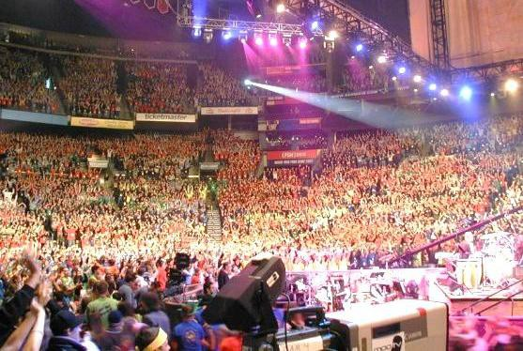

**Will participants miss any school?** NCYC high school participants will miss all or part of school on Thursday, November 20, and all of school on Friday, November 21. We believe that NCYC is well worth this sacrifice and inconvenience. Some schools may give excused absences. Most teachers will work with the students, especially given plenty of notice. NCYC will provide a generic letter that students can give to their school officials this fall explaining NCYC to school officials. Neither the NFCYM nor the archdiocese has any control over schools allowing or disallowing excused absences for NCYC.



“I feel God closer to me. When we would sing a song, I would listen to the words, and it was sending a good message to me, and it would just make me cry. All of the speakers’ stories really touched my heart and I realized that anything is possible when you put your heart and mind into it. I feel like my faith has gotten bigger.”

*— 17 year old NCYC Participant*

# Lodging, Transportation, and Meals

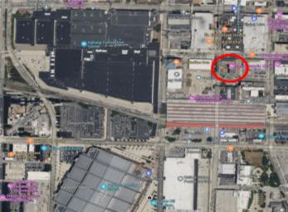**Where will we be staying?** We have a great hotel location only a block from the convention center! Our hotel is the [Omni Severin Hotel](https://www.omnihotels.com/hotels/indianapolis-severin) in the heart of downtown Indianapolis. We will have a three-minute walk to the Indiana Convention Center and a ten-minute walk to Lucus Oil Stadium. Youth sleeping rooms will have four students in each room (two in each bed) and adult sleeping rooms will have two adults in each room (one adult in each bed). While we will try to keep groups together in sleeping rooms, some rooms will have a mix of participants from different parishes and schools. *Participants registered for the ArchLou NCYC package must stay in the archdiocesan hotel and cannot make their own NCYC hotel arrangements*.

**Is a coach bus included in the archdiocesan package?** Yes. The archdiocese has arranged for coach buses to transport our NCYC pilgrims from Kentucky to Indianapolis on Thursday, November 20 and return us on Sunday, November 23. Pick-up and drop-off hubs will be announced in October. Parishes and schools are responsible for arranging for their pilgrims to get to the assigned pick-up and drop-off hub. All pilgrims registered with the Archdiocese of Louisville must travel on our buses unless permission to travel otherwise is granted by the Office of Youth and Young Adults.

**What meals are included?** No meals are included in the Archdiocese of Louisville NCYC package. Meals are the responsibility of the parish or school or the individual pilgrim. Participants will need to bring

spending money for meals not organized by the parish. We expect food options at the Indiana Convention Center and Lucus Oil Stadium. In addition, there are numerous restaurants and fast food locations in downtown Indianapolis (if a group wishes to eat a meal at a restaurant, reservations are strongly recommended). Some parish groups may choose to organize sack lunches or some group meals. Because we have room in the luggage bays of our buses, parishes are allowed to bring some food and coolers to our hotel to make simple grab-and-go breakfasts or sack lunch meals for their pilgrims. There are limited grocery store options in downtown Indianapolis, but group leaders are allowed to walk or rideshare to a local grocery store to pick up some food. We expect our hotel rooms to have small “mini-refrigerators.”

# Cost

## How much will it cost? What is included?

*Note that NCYC tickets/passes are already included in our ArchLou NCYC package,*

*so parishes and schools should not purchase NCYC tickets or passes at the NFCYM website.*

To make things easier for our parishes and schools, the Office of Youth and Young Adults has put together a comprehensive NCYC package that includes NCYC ticket/pass fees, three nights of lodging, round-trip bus service from Kentucky to Indianapolis, archdiocesan swag, and an on-site volunteer archdiocesan support team. The ArchLou package varies in price depending on when you make your deposits and ranges from $500 to $625 per person. The archdiocese will only accept registrations from ArchLou parishes and Catholic high schools on behalf of their group participants. The Office of Youth and Young Adults will make every effort to keep costs down and reserves the right to add additional charges, if necessary.

**What’s not included?** Meals, snacks, or souvenirs are not included in the archdiocesan package.

**Are parishes and schools required to organize fundraisers for NCYC?** While parishes and schools are not required to organize fundraisers, most do so in order to offset their participants’ costs for NCYC. The archdiocese encourages parishes and schools to hold communal fundraisers not only to reduce fees but also to build community within your group and raise the entire parish’s awareness of your group’s efforts to attend NCYC.

**Are scholarships available?** Thanks to a grant from the [Catholic Education Foundation](https://ceflou.org/), each ArchLou NCYC package participant will automatically receive a generous discount lowering the package price for each participant by approximately $125. No action is necessary to obtain this subsidy for ArchLou NCYC package participants since this discount is already reflected in the package price. This discount is only available for participants registered for the ArchLou NCYC package. We are grateful for CEF’s support for our NCYC pilgrimage.

NCYC offers needs-based individual and group scholarships that only cover the NCYC ticket fee and not

the ArchLou hotel, bus, and miscellaneous costs. Parish or school group leaders can request these NCYC scholarships directly and do not need to involve the archdiocese. If awarded an NCYC scholarship, please contact the Office of Youth and Young Adults so we can adjust your ArchLou NCYC package fee. More NCYC scholarship information can be found at [https://ncyc.us/scholarships](https://ncyc.us/scholarships/).

**Is the archdiocese making money on this event?** The archdiocese sets our package rate to cover all costs associated with this event. We do not bump up fees to make any profit. We took many factors into consideration, including NCYC ticket/pass fees, housing fees, giveaways, risk management, and staff costs. While the ArchLou NCYC package fees do cover the travel, meals, and lodging expenses for volunteers on the archdiocesan NCYC onsite support team, *the countless hours of archdiocesan staff work for this event are a service of the archdiocese and not charged to our NCYC participants*.

# Organizing Parish Groups

**Who organizes NCYC at the parish or school level?** Since participants must register through their parish or school, each parish or school must identify one adult as their NCYC “Group Leader.” This person is the single point of contact and a vital communication link between that parish and the archdiocese. The parish or school NCYC group leader may or may not be the primary NCYC organizer at their location. The Group Leader, with support from an optional local NCYC planning team, must stay on top of deadlines, making payments to the archdiocese, collecting payments from youth, managing fundraising efforts, and collecting the many required forms. The archdiocese is here to assist group leaders, so do not hesitate to contact us for questions.

**What are the initial steps to get our parish or school organized?** After carefully reading through these FAQs, the first step is to share all of this information with your pastor, parish leadership, and key youth ministry leaders. The more the parish knows about NCYC, the more likely they are to support your efforts. This support may be financial, organizational, and/or spiritual.

We recommend that you form a parish NCYC Planning Team to help make decisions and share the workload. Establish a parish timeline that allows you to meet the archdiocesan timeline. What fundraising strategies will you employ? How will you handle arranging travel?

Decide how you can promote NCYC in your parish. Some parishes hold an information meeting and share the information. Some promote it at their youth gatherings or send promo flyers and the [NCYC promo](https://youtu.be/FZVZJ_6HUKs) [video](https://youtu.be/FZVZJ_6HUKs) to eligible youth. Remember that students must be in high school for the 2025-2026 school year. Look for NCYC promotional material at [https://ncyc.us/group-leaders/promo-materials](https://ncyc.us/group-leaders/promo-materials/).

**How does the ArchLou NCYC package registration work?** The ArchLou NCYC package consists of two parts: Part A and Part B.

**Part A.** Part A ($215) is a fixed amount that includes the hotel, bus, and other archdiocesan costs (the CEF grant is already rolled into this fee).

**Part B.** Part B ($285-$410) is a varied amount that includes the NCYC ticket/pass. The archdiocese will purchase this pass at our member-discounted rate from NFCYM and charge you the same amount without any markups. The fee for Part B and its due dates can be seen in Table 1.

There are two types of payments: Deposits and Balances Due. The deadlines and amount for each type of payment are listed in Table 1

**Deposit.** This is the required amount to hold a place in the ArchLou NCYC Pilgrimage. The deposit must be received at the archdiocese by the listed due date in order to qualify for that rate. To get the best rate, parishes and schools must pay their deposit by April 22, 2025.

**Balance Due.** All fees must be paid in full by this date.

|  |  |  |  |  |  |  |
| --- | --- | --- | --- | --- | --- | --- |
| **Table | Deposits and Balances Due** | | | | | | |
| **Deadline** | **Date Due** | **Part A** | **Part B** | **Total** | **Deposit due** | **Balance due** |
| 1 | April 22 | $215.00 | $285.00 | **$500.00** | $285 by April 22 | $215 by August 21 |
| 2 | August 21 | $215.00 | $335.00 | **$550.00** | $335 by Aug 21 | $215 by August 21 |
| 3 | October 15 | $215.00 | $360.00 | **$575.00** | --- | $575 by October 15 |
| 4 | October 24 | $215.00 | $410.00 | **$625.00** | --- | $625 by October 24 |

Once you know how many participants will be attending from your parish or school, you’ll send in your deposits (in a single payment along with *Form A-NCYC Parish/School Registration and Deposit,* available at [www.archlou.org/youth](http://www.archlou.org/youth) to the archdiocese. Note that you will *not* need to provide names at that time, so you can easily make substitutions at this stage with no consequences. Soon after you send in your deposit, the archdiocese will email you your NCYC passes via the NFCYM portal. You can then send the passes (via the NFYCM portal) to a parent or guardian of each of your NCYC students, as well as your NCYC adults. You may also be able to transfer tickets to other students or adults in case you have cancellations. We’ll explain this in more detail when we reach that stage.

**Are NCYC Passes nonrefundable? Can they be transferred?** If you make a deposit and the archdiocese purchases one or more NCYC passes on your behalf, those passes are yours and are nonrefundable. While you are not able to return NCYC passes, you may be able to transfer them to new members of your group. You may be able to “sell” and transfer them to another ArchLou parish or school in need of additional passes. We will have more information on this process at a later time.

**What is the refund policy?** Part B of your payments (NCYC passes) is nonrefundable but may be transferable. Part A (hotel, bus, etc.) of your payment may be refundable

“For me NCYC was astonishing. As an adult chaperone I was constantly amazed at the compassion and love I observed in our youth. The spirit was definitely alive in the arena when we gathered as thousands of Catholics speaking with one voice.”

*— NCYC Adult Chaperone*

if the funds have not yet been committed. A $25 cancellation fee may apply to any approved refunds. No refunds are available after October 15, 2025.

**When will the archdiocese need the names of my participants and chaperones?** When we send you your NCYC passes via the NFCYM

portal, you can hold them until your group participants have firmed up, or you can immediately “send” them to your students’ parents or your adults. The archdiocese will also collect your participants’ names and contact information this summer.

**What about safety and security?** Everyone involved in NCYC wants to do everything possible to safeguard and protect our young people at NCYC. All adult chaperones at NCYC must be screened and trained according to their archdiocesan Child Protection policies. Group Leaders will be responsible for maintaining proper chaperone coverage of their youth during NCYC. NCYC participants and chaperones will be issued NCYC credentials, and no one will be admitted into NCYC venues without proper credentials. All backpacks and bags brought into the NCYC venues are subject to search. The NFCYM and the local Indianapolis authorities are working together to ensure a safe conference.

**I want to put the NCYC logo on my promotional material or group t-shirts. Where can I get a copy?** The NCYC logos are copyrighted, and there are strict guidelines for their usage. To inquire about using the NCYC logos in local promotional material and apparel, email [communication@nfcym.org](mailto:communication@nfcym.org). *Not following those rules is copyright infringement, a sin, and a crime.*

**What if I have a student with special needs?** The archdiocese and NCYC welcome high school students to NCYC and will work with you to make proper accommodations. If you have a student or chaperone with a special need, please contact the Office of Youth and Young Adult Ministry.

**Can youth from another parish or school come with my parish?** In cases where a parish or school may not be participating in NCYC, the archdiocese, on a case-by-case basis, may allow “orphan” students to be “adopted” by a parish or school organizing an NCYC group. The adopting parish or school must accept full responsibility for the student(s) and he or she should be treated just as if they were members of that parish. Of course, parents must approve, and the adopting parish is responsible for adequate chaperone coverage (1 for 6) with the additional student(s) as part of their group. Contact the Office of Youth and Young Adults if this situation arises.

**How can I get more information?** Contact [NCYC@archlou.org](mailto:NCYC@archlou.org%20) or contact the **Coordinator of NCYC for the Archdiocese of Louisville, Jonna O’Bryan at 812 449-6560.**

**Additional NCYC Group Leader Resources**

*The following are past NCYC blog posts by NFCYM, the organizer of NCYC. While the blog posts below were created for previous NCYCs, and some specific details may no longer apply, the general information should still be applicable.*

*For the latest NCYC blogs posts from NFCYM, visit* [*https://ncyc.us/resources-and-updates/*](https://ncyc.us/resources-and-updates/)*.*

***Leading a Parish/School Group at NCYC***

* Why NCYC is a Pilgrimage - <https://ncyc.us/pilgriming-to-ncyc/>
* Five Things to Know as a New NCYC Parish/School Leader - <https://ncyc.us/5-things-to-know-as-a-new-leader/>
* What Group Leaders are Asking about NCYC with Answers - <https://ncyc.us/zoom-qa/>
* NCYC for High School Campus Ministry - <https://ncyc.us/campus-ministry-off-campus/>

***Explaining NCYC to Youth and Parents***

* Youth to Youth: Why You Should Go to NCYC! - <https://ncyc.us/youth-to-youth/>
* How NCYC Transformed our Children - <https://ncyc.us/how-ncyc-transformed-our-children/>
* Finding My Vocation: From NCYC to Religious Life - <https://ncyc.us/finding-my-vocation-from-ncyc-to-religious-life/>

***Fundraising Ideas***

* Fundraising Ideas for NCYC Parishes/Schools - <https://ncyc.us/fundraising-for-youth-travel-programs/>

All About Fundraising blog post - <https://ncyc.us/ncyc-101-5-all-about-fundraising/>