



**NCYC**

**2025 Pilgrimage**

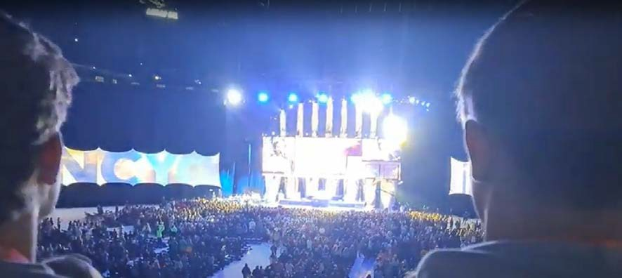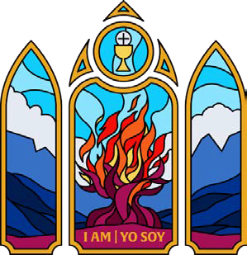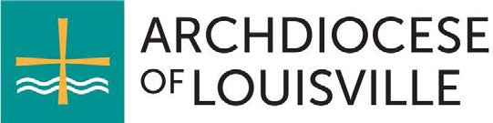

# Essential Information

## Overview of NCYC

The National Catholic Youth Conference (NCYC) is a multi-day event for high school students and chaperones, offering opportunities to deepen faith, connect with the broader Church, and participate in activities like inspiring sessions, worship, reconciliation, Eucharistic Adoration, concerts, and exhibits. For more details, visit: [www.archlou.org/youth](http://www.archlou.org/youth)

## Organizers

NCYC is organized by the National Federation for Catholic Youth Ministry (NFCYM). The Archdiocese of Louisville (ArchLou) is a member, which helps reduce costs for our delegation.

## Role of the Archdiocese

The Office of Youth and Young Adults (OYYA) manages all logistics—registration, transportation, lodging, and risk management—allowing parish and school leaders to focus on their youth. Each parish or school organizes its own group as part of the ArchLou delegation.

## Event Details

* **Dates:** November 20-23, 2025
* **Location:** Indianapolis, IN (Lucas Oil Stadium & Indiana Convention Center)
* **Departure:** Thursday, November 20 (returning Sunday, November 23)
* **School Impact:** Students will miss part or all of school on November 20 & 21

**2025 Theme: *I Am | Yo Soy***

Inspired by God’s appearance to Moses in the burning bush, this theme explores how the Sacraments connect us to God’s love and salvation.

## Archbishop Shelton's Attendance

Tentatively, yes! He plans to join us on Friday of NCYC.

## Participation Capacity

We have room for approximately 300 participants. If we fill up, we’ll start a waitlist and explore expansion options.

## Notable Changes from 2023

* **Extended Stay:** Now includes Thursday, Friday, and Saturday nights.
* **New Hotel:** A more convenient location, eliminating early bus loading on Saturday.
* **Young Adult Assistants (YAAs):** A new role for 18-20-year-olds who have graduated high school.
* **Streamlined Ticketing & Waivers:** Managed through the NFCYM portal for easier distribution.
* **Chaperone Requirements:** Background checks & Safe Environment training required before registration.

# Participation Eligibility

## Youth Participants

* Must be in high school during the 2025-2026 school year.
* 18+ high school students are still considered minors for this trip.

## Chaperones

* Must be 21+ and meet Safe Environment & background check requirements. **Note:** *Adult chaperones and young adult assistants must complete and have their background checks and Safe Environment training verified by the archdiocese before registering for NCYC.*
* Ratio: 1 adult per 6 youth.
* Parents can serve as chaperones if they meet requirements.

## Priests, Deacons, & Seminarians

* Encouraged to attend with their parish group.
* Can count toward chaperone ratios if acting in a full-time chaperone role.

## Young Adult Assistants (YAAs)

* Aged 18-20 and out of high school.
* Assist with leadership tasks but **do not** count as chaperones.
* Must maintain an adult leader role, not a youth participant role.

## Benefits of Attendance

* Deepen faith and relationship with Christ.

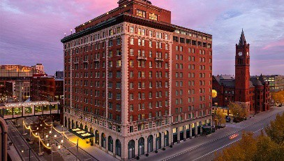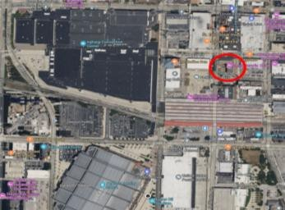

* Celebrate Catholic faith with thousands of young Catholics.
* Grow in understanding of vocation and mission.

# Logistics

## Lodging

* **Omni Severin Hotel** – a block from the convention center.
* Youth rooms: 4 students per room (2 per bed).
* Adult rooms: 2 adults per room (1 per bed).

## Transportation

* Coach buses included in the package.
* Departure & return hubs will be announced in October.
* All participants must travel with the ArchLou group unless given special permission.

## Meals

* **Not included** in the package.
* Participants should bring money for meals.
* Group leaders may organize food options (coolers, sack lunches, etc.).

# Financial Information

## Cost Per Person

* + **$500 - $625**, depending on deposit timing.(See Attached Registration & Deposit- Form A)
  + Includes NCYC pass, lodging, transportation, and ArchLou support.
  + Fundraising is encouraged but not required.

## Scholarships

* + Each participant automatically receives a **$125 discount** from the Catholic Education Foundation (CEF). **Note:** *This discount is exclusively available to participants registered for the ArchLou NCYC package.*
  + Additional **needs-based scholarships** available through NCYC.

## Exclusions

* + Meals, snacks, souvenirs.

# Group Organization

## Group Leadership

Each parish or school must designate a **Group Leader** to handle registrations, payments, and logistics.

## Steps to Get Started

1. **Inform** pastors, youth leaders, and families.
2. **Form a Planning Team** for fundraising and logistics.
3. **Promote NCYC** in youth gatherings, bulletins, and flyers. Promotional materials are available at <https://ncyc.us/group-leaders/promo-materials>
4. **Register Your Group** through the ArchLou package.

For a more detailed NCYC 2025 Pilgrimage Group Leaders Information (FAQ) visit: NCYC25 Group Leader Info FDB.docx

For questions, contact **Jonna O’Bryan, Coordinator for NCYC for Office of Youth and Young Adults** at [NCYC@archlou.org](mailto:NCYC@archlou.org) or 812 449-6560**.**

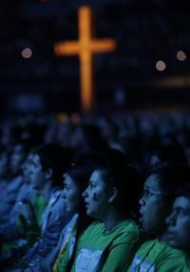

**Let’s make NCYC 2025 an incredible faith journey!**